|  |
| --- |
| **Year 11 Specialist Mathematics**  Semester 2, October 2020  **Test 6: Complex Numbers and Number Proofs**  **Calculator Free Weighting: 6%**  **[Australian Curriculum Reference Numbers: 2.3.1 - 2.3.16]** |

**Total Time: 50min Total Marks = $\frac{}{50}$**

**Student Name: SOLUTIONS**

**Teacher: ___________________________________**

**INSTRUCTIONS TO STUDENTS:**

* You **are not allowed** a calculator or any notes.
* A formula booklet will be provided.

You are required to attempt ALL questions.

Write answers in the spaces provided beneath each question.

Marks are shown with the questions.

**Show all working** clearly, in sufficient detail to allow your answers to be checked readily and for marks to be answered for reasoning. Incorrect answers given without supporting reasoning cannot be allocated any marks. For any question or part question worth more than two marks, valid working or justification is required to receive full marks.

1. Given that $z=3-i$ and $w=2i-3$, determine the following:   
    (express your answers in the form $a+bi$, where $a$ and $b$ are real)

|  |
| --- |
|  |

Image result for red tick no backgroundImage result for red tick no background

|  |
| --- |
|  |
|  |

Image result for red tick no background

|  |
| --- |
|  |
|  |
| *** Do not deduct a mark for not including $0i$, although they may lose a mark in WACE exams*** |

Image result for red tick no backgroundImage result for red tick no background

|  |
| --- |
|  |
|  |
|  |
| Image result for red tick no background |

[1,2,1,3 = 7 marks]

1. Prove that any complex number multiplied by its conjugate will always give a real number.

|  |
| --- |
| $Let z=a+bi$, where a and b are real. |
| Image result for red tick no backgroundImage result for red tick no backgroundImage result for red tick no backgroundThen |
|  |
|  |
|  |

[3 marks]

1. Prove that ${ 1}^{3}+2^{3}+3^{3}+4^{3}+…+n^{3}=\frac{n^{2}}{4}{\left(n+1\right)}^{2}$, for every positive integer $n$.

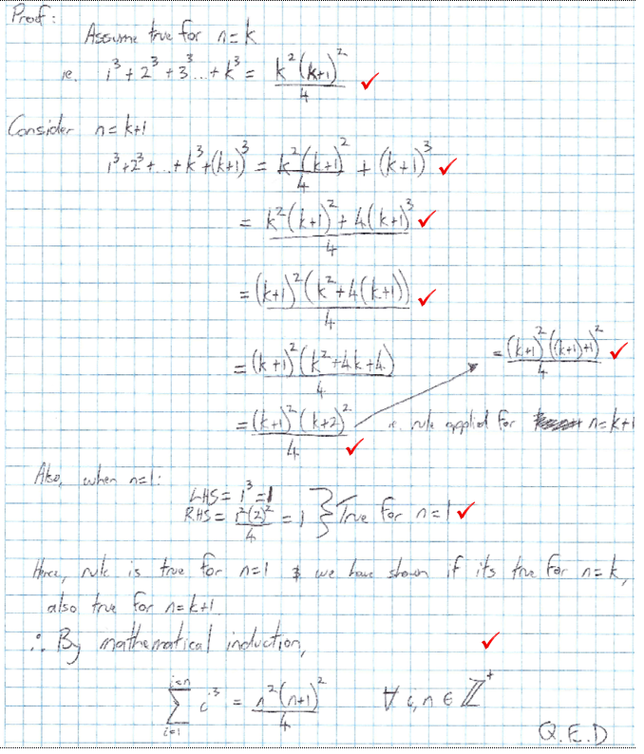

**[8 Marks]**

1. For the equation
   1. Image result for red tick no backgroundImage result for red tick no backgroundImage result for red tick no backgroundImage result for red tick no backgroundImage result for red tick no background***Show*** that is a complex solution.

|  |
| --- |
|  |
|  |
|  |
|  |
|  |
|  |
|  |
|  |
|  |

* 1. Image result for red tick no backgroundImage result for red tick no backgroundImage result for red tick no backgroundDetermine the other two solutions to the equation $x^{3}-1=0$ and hence factorise $x^{3}-1$.

|  |
| --- |
| $$Complex conjugate of x=\frac{-1+i\sqrt{3}}{2} is another solution$$ |
| $$Also, x=1 is a solution.$$ |
| $$∴x^{3}-1 factorises to$$ |
| $$\left(x-1\right)\left( x-\frac{-1-i\sqrt{3}}{2}\right)\left(x-\frac{-1+i\sqrt{3}}{2} \right) or$$ |
| $$\left(x-1\right)\left( x+\frac{1+i\sqrt{3}}{2}\right)\left(x+\frac{1-i\sqrt{3}}{2} \right)$$ |
|  |
|  |
|  |
|  |
|  |

**[5,3 = 8 Marks]**

1. Sketch the complex numbers as vectors on the Argand Diagram below. $$z_{1}=1-2i, { z}_{2}=\frac{3}{-i}, { z}_{3}=i^{7}z_{1}, { z}_{4}=\overline{z_{2}}, { z}_{5}=\frac{1}{9}z_{1}z_{2}z_{3}z_{4}$$

|  |
| --- |
| $$z_{2}=\frac{3i}{-i^{2}}=3i$$ |
|  |
| $$z_{3}=-i\left(1-2i\right)=-i-2$$ |
|  |
| $$z_{4}= -3i$$ |
| $$z_{5}=\frac{1}{9}(1-2i)(3i)(-i-2)(-3i)$$ |
| $$=\frac{1}{9}-9i^{2}(1-2i)(-i-2)$$ |
| $$=\left(-i-2+2i^{2}+4i\right) ∴z_{5}=(-4+3i)$$ |

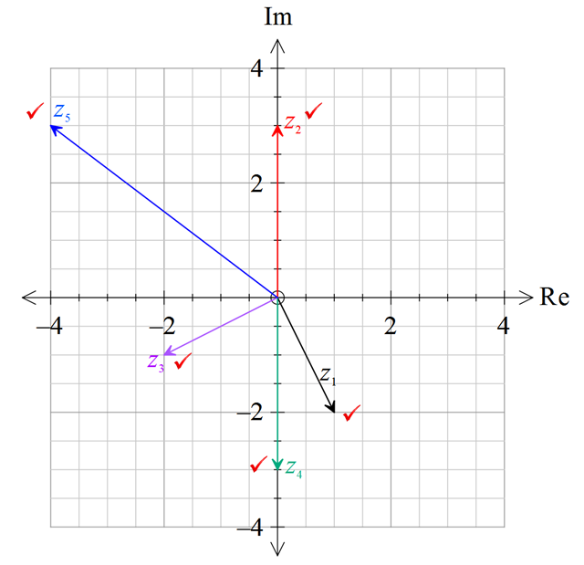

[5 marks]

1. Image result for red tick no backgroundImage result for red tick no backgroundImage result for red tick no backgroundComplete the square to express $x^{2}+14x+53$ as a product of linear factors.

|  |
| --- |
| $${=\left(x+7\right)}^{2}-49+53$$ |
| $$={\left(x+7\right)}^{2}+4$$ |
| $$={\left(x+7\right)}^{2}-{\left(2i\right)}^{2}$$ |
| $$=(x+7-2i)(x+7+2i)$$ |

[3 marks]

1. For the Argand Diagrams below:

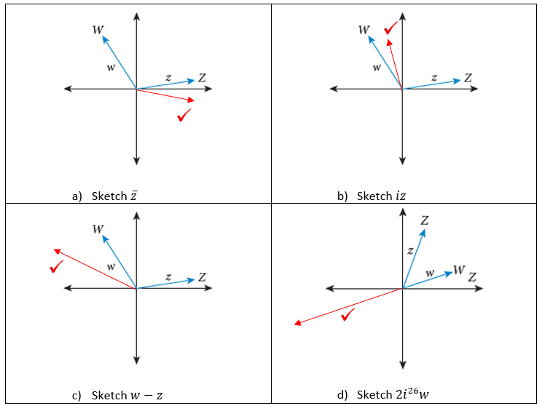

[4 marks]

1. Image result for red tick no backgroundImage result for red tick no backgroundImage result for red tick no backgroundImage result for red tick no backgroundConvert the decimal $2.40\overline{7}$ into the form $\frac{a}{b}, a,b∈ Z^{+}$ where $a and b$ are coprime.

|  |
| --- |
| $$Let x=2.40\overline{7}$$ |
| $$100x=240.\overline{7}$$ |
| $$1000x=2407.\overline{7}$$ |
| $$900x=2167$$ |
| $$x=\frac{2167}{900}$$ |
|  |
|  |
|  |

[4 marks]

1. By exhausting all possible cases, prove that there are no rational solutions to the equation:

$$x^{3}+x+3=0$$

|  |
| --- |
|  |
|  |
|  |
|  |
|  |
|  |
|  |
|  |
|  |
|  |
|  |
|  |
|  |
|  |
|  |
|  |
|  |
|  |
|  |
|  |
|  |
|  |

**[8 Marks]**

**\*\*\* End of Test \*\*\***

***Extra space for working out***



  
  
  
  
  
  
  
  
  
  
  
  
  
  
  
  